**8. Charts and Repos**

* Helm uses the concept of charts, which are like packages to install a particular application to the Kubernetes cluster and these packages are charts are stored in a chart repository.
* Now we will see one popular chart repository we are going to use throughout this course.
* Later, we will learn how to create your own repositories or host your own repositories, create your own charts, and host them in the repositories as well.

**Bitnami**

--- Go to https://bitnami.com/stacks/helm

--- this bitnami is a very popular repository that hosts different kinds of things, including Helm repository that has different charts.

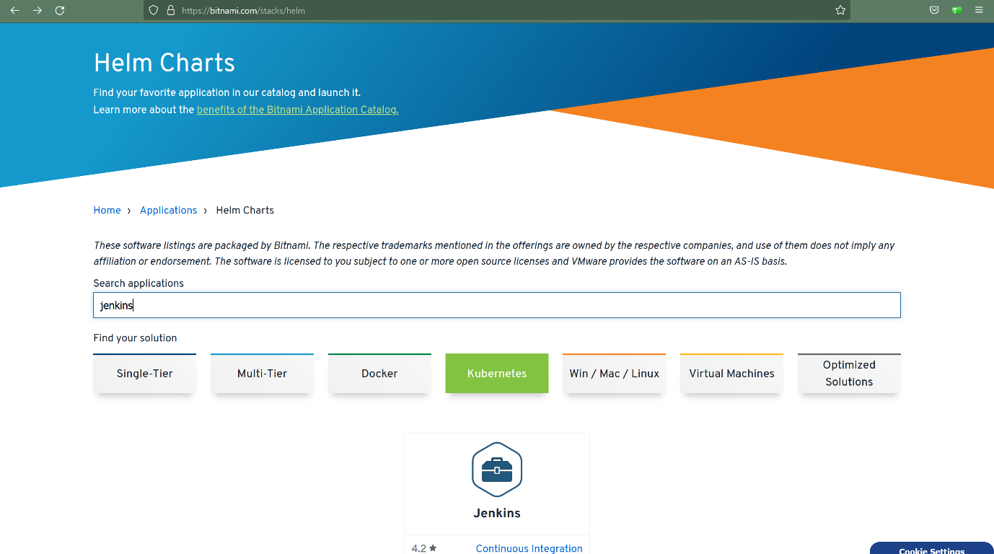

--- here you can search for which ever application you want to install to the Kubernetes cluster. for example, jenkins and it will show you the search results here.

--- click on the chart.

